Lab 3
Event Handling

SafeRoute AI - Web Page Enhancement Submission
1. Source Code
*(Note: Since your application uses a decoupled HTML/JS architecture, here are the core snippets from your frontend codebase containing the integrated DOM Events.)*

javascript
// ==========================================
// ACADEMIC EVENT MAPPINGS (script.js)
// ==========================================

// 1. KEYBOARD EVENT (keydown)
document.addEventListener("keydown", (e) => {
const sosModal = document.getElementById("sosModal");
if (e.key === "Escape" && sosModal && !sosModal.classList.contains("hidden")) {
sosModal.classList.add("hidden");
if (window.showToast) window.showToast("Canceled", "Emergency SOS modal dismissed via Escape key.", false);
}
});

// 2. MOUSE EVENT (dblclick)
const mapNode = document.getElementById("interactiveMap");
if (mapNode) {
mapNode.addEventListener("dblclick", () => {
if (window.showToast) window.showToast("Map Interactive", "Double click registered on Live AI Tracking Map.", false);
});
}

// 3. CLIPBOARD EVENT (copy)
const riskResultNode = document.getElementById("predictionResult");
if (riskResultNode) {
riskResultNode.addEventListener("copy", (e) => {
const selection = document.getSelection();
e.clipboardData.setData('text/plain', selection.toString() + "\n\n-- Generated autonomously by SafeRoute Neural Engine API");
e.preventDefault();
if (window.showToast) window.showToast("Data Secured", "Copied AI output to clipboard with verification watermark.", false);
});
}

// 4. FORM EVENTS (focus & blur & submit)
const destSelect = document.getElementById("destination");
const aiSubmitBtn = document.querySelector("#riskForm button[type='submit']");
if (destSelect && aiSubmitBtn) {
destSelect.addEventListener("focus", () => {
aiSubmitBtn.classList.add("ring-4", "ring-cyan-500", "ring-offset-2", "scale-105");
});
destSelect.addEventListener("blur", () => {
aiSubmitBtn.classList.remove("ring-4", "ring-cyan-500", "ring-offset-2", "scale-105");
});
}
```

---

2. Event Integration Screenshots

1 Keydown / Keyup Event
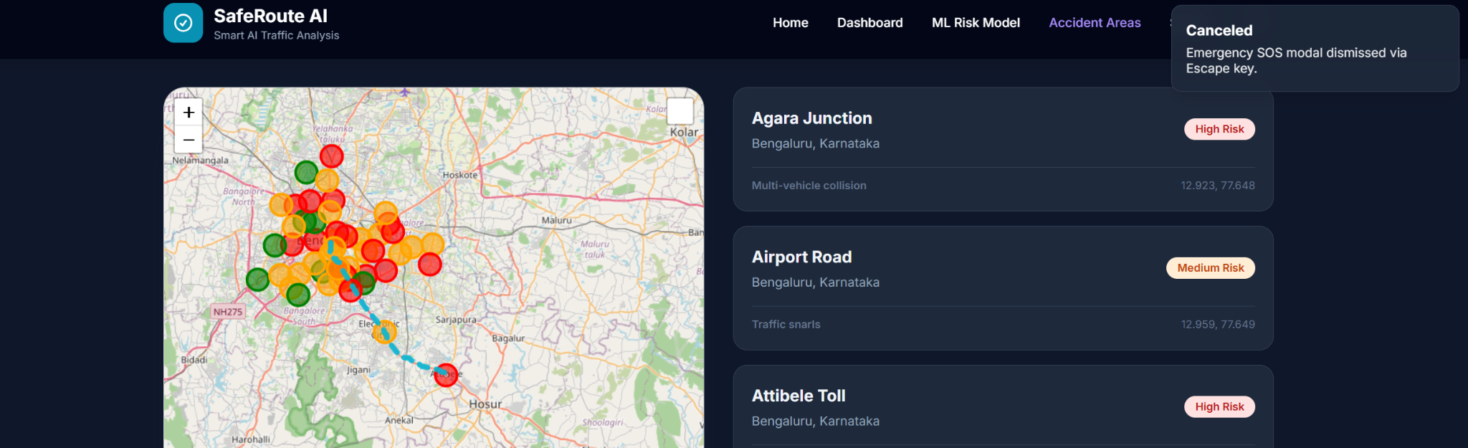

2 Double-Click Event
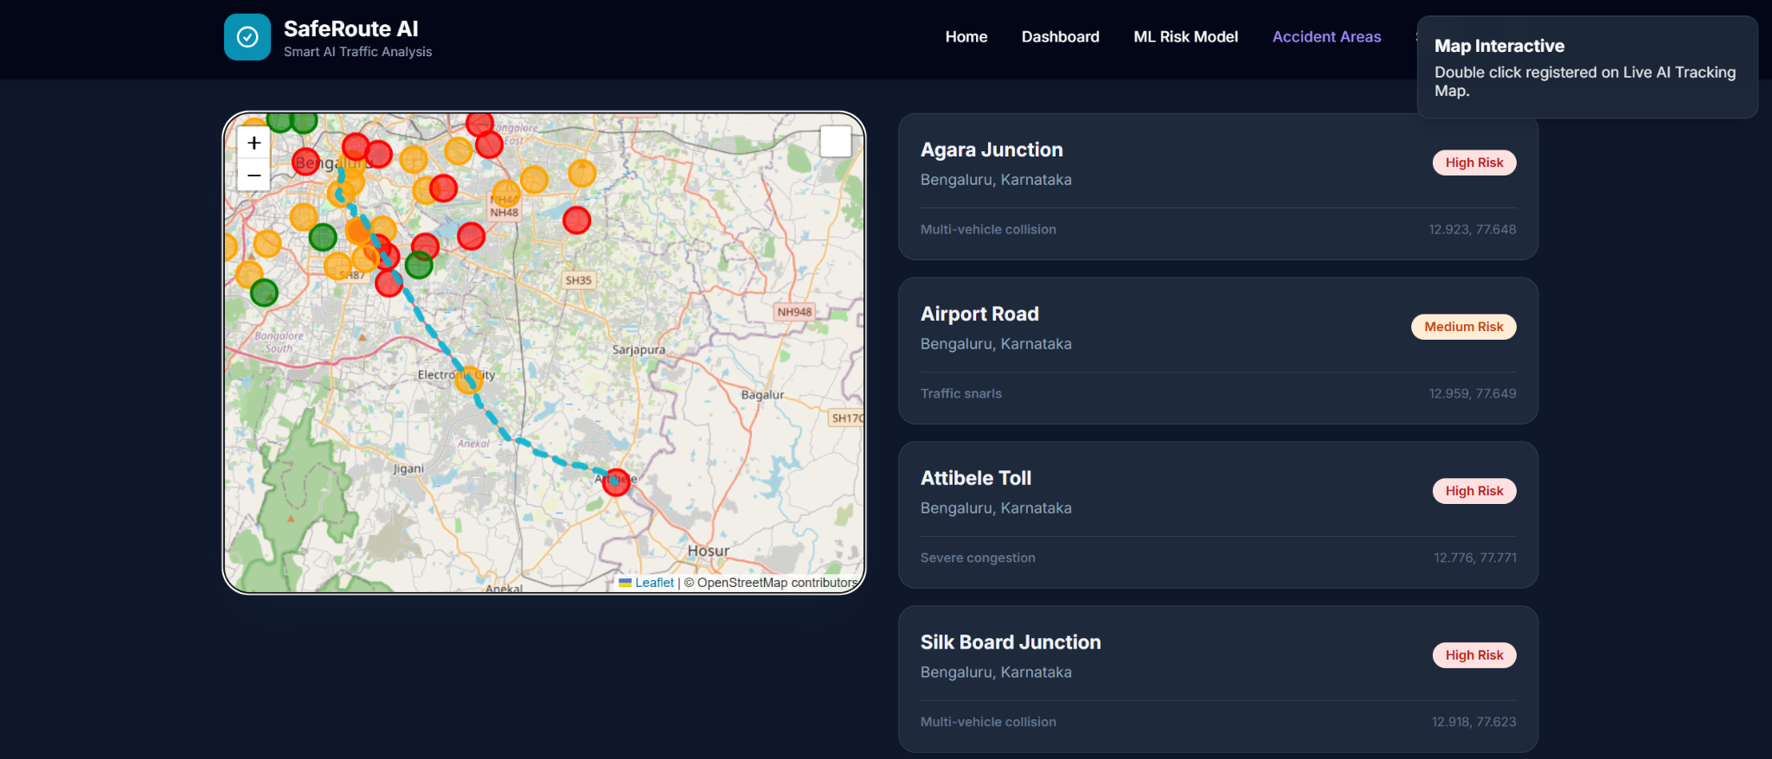
3 Focus / Blur Form Events
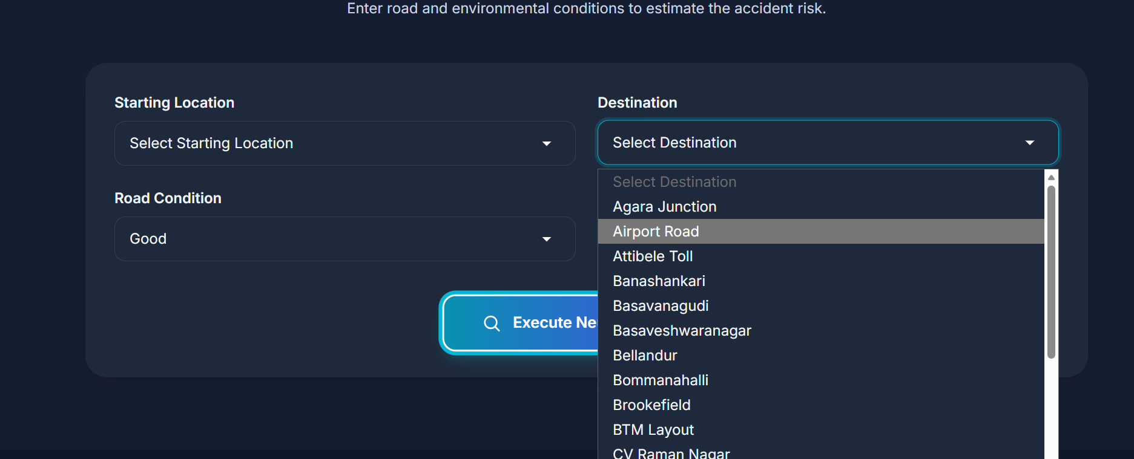

4 Copy Event
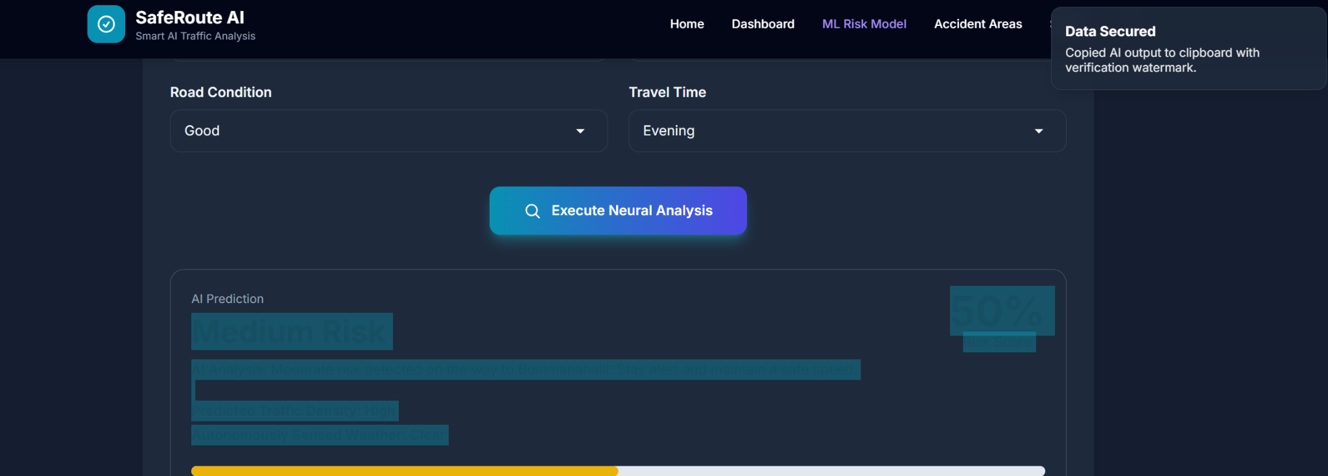

3. GitHub Repository Link

Repository Title: SafeRoute-Echanced
URL:

4.AI Usage Declaration

AI Tools Utilized:
Advanced Large Language Models (LLM / AI Coding Assistants).

Purpose of AI Assistance:
During the engineering and expansion of the SafeRoute AI platform, artificial intelligence was utilized exclusively as a sophisticated pair-programming assistant. The primary applications of AI included:

1. Syntax Prototyping: Generating CSS/Tailwind boilerplate to assist in building the responsive "Glassmorphism" UI aesthetics.
2. Event & Bug Diagnostics: Assisting in identifying asynchronous JavaScript race-conditions (e.g., scoping `DOMContentLoaded` wrappers to bypass browser caching collisions) to ensure stable Frontend-to-Backend HTTP fetches.
3. Data Formatting: Helping to rapidly map and plot raw latitudinal/longitudinal coordinates over 47 distinct geographic locations to populate the embedded Leaflet.js matrix safely.

Academic Integrity Affirmation: The overarching architecture, conceptual direction, API integration strategies, geographical dataset expansion, and domain focus were completely original and user-driven. The AI acted purely as an assistive compiler and debugger to expedite technical hurdles.

